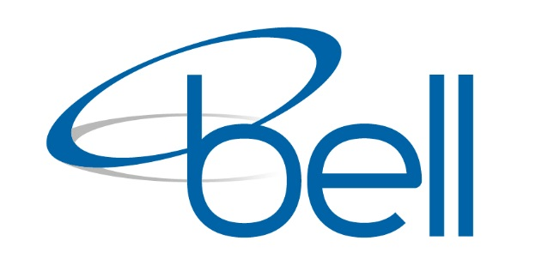

Occupational Health and Safety Policy
The Company acknowledges its Corporate Governance responsibilities for health and safety and is committed to the prevention of harm to employees and others.

The Company recognises that our management system proves a framework for the setting of objectives and targets to eliminate or minimise work related incidents and the management practices for the well-being of individuals in the workplace, as well as the safe operation and maintenance of all plant and equipment. Adequate resources will be provided to achieve this goal.

As part of our commitment, the Company shall:
- Comply with the OHS Legislation, regulations and standards that reflect, the Company’s commitment to occupational health and safety;
- Communicate and consult with employees and relevant stakeholders in the development and implementation of occupational health and safety systems that strive for continuous improvement;
- Ensure all employees take reasonable steps to prevent incidents through the implementation of company compliance and risk managements programs;
- Ensure all employees and contractors have all adequate information and training required to competently and safely perform their work;
- Ensure management actively demonstrates commitment and visible leadership to assist in the continual improvement of occupational health and safety performance;
- Accurately report, record and investigate all work related incidents and implement corrective action in consultation with employees to ensure prevention of recurrence and continual improvement of safe work practices;
- Manage compliance and operational risk, whereby the identification, assessment, control and monitoring of hazards/risks becomes a habit for all personnel;
- Demonstrate commitment to effective Injury/ Rehabilitation Management program; and,
- Review and continually improve the OHS System.
Bell Environmental recognizes that the achievement of an effective Occupational Health and Safety program demands the active and positive on-going involvement of all levels of management and the full participation and support of all employees

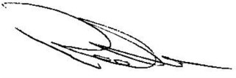
Robert Bell
Managing Director
Bell Environmental

68 Berkshire Road, North Sunshine, Victoria 3020
Tel: (03) 9311 8460 E-mail: sales@bellenvironmental.com.au Web: www.bellenvironmental.com.au

