EQUAL EMPLOYMENT OPPORTUNITY (EEO) POLICY

The company is committed to establish an employment climate and culture in which every person has the opportunity to apply and develop their abilities for the achievement of their personal best.

The principles of EEO Policy implies that a person’s race, sex, marital status, membership of an ethnic or racial group, physical disability, intellectual impairment, sexual preference or transgender status should not reduce or promote their chances of employment, promotion, training or obtaining any other benefit or opportunity related to their employment. Supervisors/Managers are responsible to ensure that employees are aware of EEO policy principles.

Merit is the basis for employment and promotion to determine the applicant’s ability to meet specific criteria only as is relevant to the duties of the position. The specific criteria to be met is: -
• Qualifications – refers to specific educational requirements in order to undertake the duties of the position (e.g. Trade Certificate)

• Abilities – refers to skills and capabilities attained through knowledge, performance and expertise relevant to effective work achievement (e.g. ability to meet tight deadlines)

• Experience – may be in any specific field or reflected by relevant practices/training/abilities (e.g. experience in automotive repairs)

• Standard – refers to the quality of work performance and/or the level of output required relating to the position (e.g. 65 wpm for a Data Entry Operator)

• Personal Qualities – refers to any specific or associated work behaviour required for the position (e.g. initiative)

EEO principles which are applied in the workplace are: -
• Employing the best person for the job only as they are relevant to the duties of the position

• Appraising, developing and promoting all employees on the basis of performance, ability and potential, having regard to employee aspirations

• Providing access to training for employees as is relevant to their responsibilities and obligations

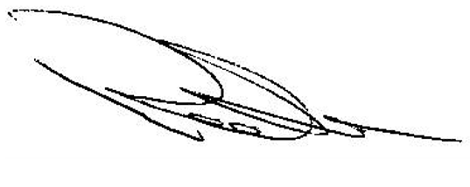

Robert Bell

Managing Director
Bell Environmental

